
CASA OF ARIZONA
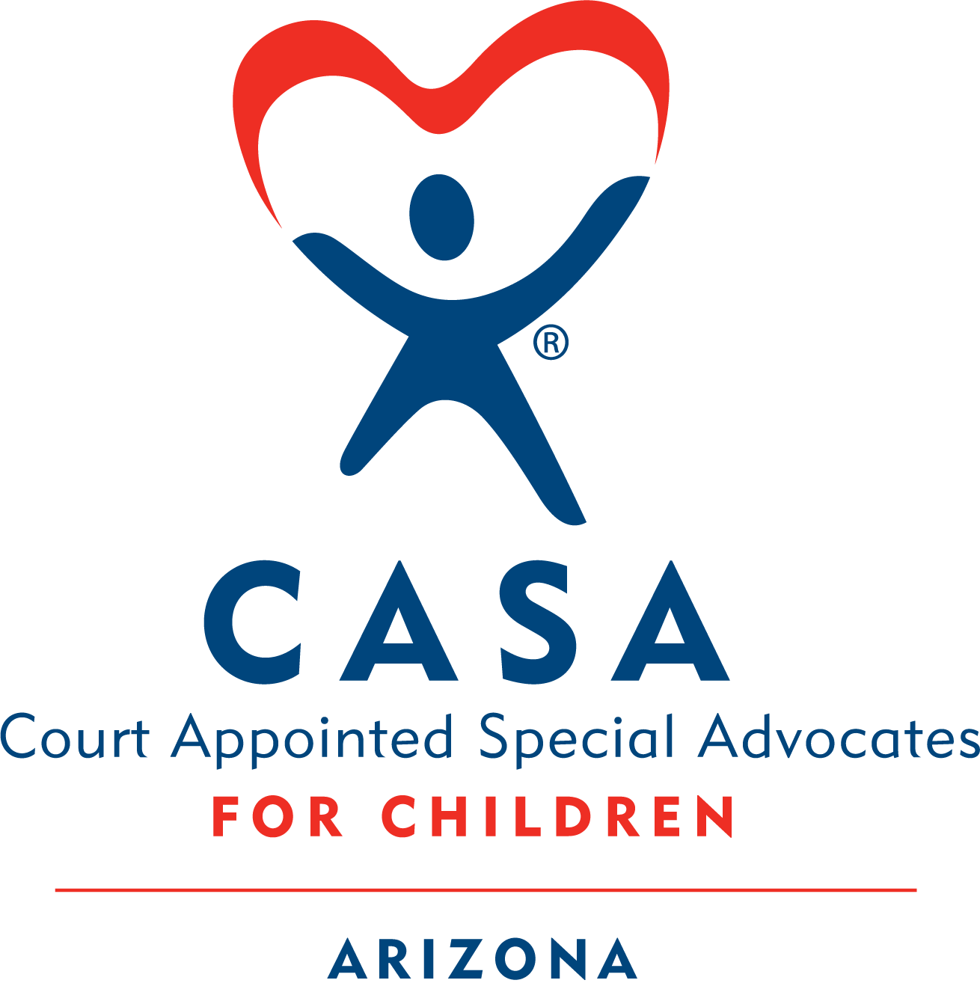
Virtual
Module 4 Homework
❖ Activity 4.1 Understanding Substance Use 2
❖ Activity 4.2 Risk Factors of Parental Substance Use 4
❖ Activity 4.3 Stages of Change 5
❖ Activity 4.4 Stigma 6
❖ Activity 4.5 Newborns Exposed to Substances: Hearing Mothers Voices 7
❖ Activity 4.6 Working with Families 8
❖ Activity 4.7 What is Culture? 9
❖ Activity 4.8 Stereotyping vs Cultural Awareness, Responsiveness & Humility 10
❖ Activity 4.9 Educational Challenges for Children in the Child Welfare System 13
❖ Activity 4.10 Rosa Case 14
❖ Activity 4.11 Assessment Section Rewriting Practice 15

Activity 4.1 Understanding Substance Use

Definitions
According to the American Society of Addiction Medicine (n.d):
Addiction is a treatable, chronic medical disease involving complex interactions among brain circuits, genetics, the environment, and an individual’s life experiences. People with addiction use substances or engage in behaviors that become compulsive and often continue despite harmful consequences.
Prevention efforts and treatment approaches for addiction are generally as successful as those for other chronic diseases (para 1 & 2).
Addiction, also called substance use disorder, involves the following:
• Persistent pattern of repeated substance use resulting in a strong internal drive to continue use
• Development of increasing tolerance to the substance
• Withdrawal symptoms when the drug use is reduced or stopped
• Continued use despite significant substance related problems
(APA, 2023, para 1)

Causes
There are different theories about how substance use disorders start and what causes them. According to the American Society of Addiction Medicine, substance-related disorders are biopsychosocial, meaning they are caused by a combination of biological, psychological, and social factors.
It is important to remember that people suffering from substance use disorders are not choosing to be in the situation they are in. Try to see those who are impacted by addiction as separate from their disease. In other words, they should be seen as “sick and trying to get well,” not as “bad people who need to improve themselves.” This will help you remember to be compassionate and nonjudgmental in your approach.

Treatment
Addiction treatment looks at the whole person—not just the substance use. It should be tailored to each individual’s needs, based on a full understanding of their life and family situation.

Treatment can include different types of support, depending on how serious the addiction is. This might range from a simple referral to a 12-step program, to outpatient counseling, day-treatment programs, or even residential treatment.
Treatment programs often include:
- Assessments
- Individual, group, and family counseling
- Educational sessions
- Aftercare and continuing support
- Referrals to 12-step or recovery groups
- Medication-assisted treatment (MAT)

Harm Reduction
Definition: “Harm reduction incorporates a spectrum of strategies that includes safer use, managed use, abstinence, meeting people who use drugs where they’re at, and addressing conditions of use along with the use itself" (National Harm Reduction Coalition).
Recovery is a journey—and setbacks can be part of it.

It’s helpful to understand the difference between a lapse and a relapse:
- A lapse is a brief return to substance use, followed by quickly getting back on track.
  - For example, an individual who has been triggered and turns to substance use to cope, but quickly begins implementing the skills they learned through their recovery process
- A relapse is when an individual returns to using substances at the same frequency and usage as they had prior to treatment.

Prevalence
“Parental addiction is a significant factor in child abuse and neglect cases, with studies suggesting 60% to 80% of families in the child welfare system are affected by addiction (National Center on Substance Abuse and Child Welfare, 2023).”
It is helpful to remember that children of parents living with substance use issues still love their parents, even though the parents may have abused or neglected them.

Substance Use Disorders

- In 2022, 48.7 million people aged 12 or older (or 17.3%) had a substance use disorder (SUD) in the past year, including 29.5 million who had an alcohol use disorder (AUD), 27.2 million who had a drug use disorder (DUD), and 8.0 million people who had both an AUD and a DUD.
- Among the 29.5 million people aged 12 or older in 2022 with a past year AUD, most (59.1%) had a mild disorder compared with about 1 in 5 (20.7%) who had a severe disorder.
- Among the 19.0 million people aged 12 or older in 2022 with a past year marijuana use disorder, most (55.1%) had a mild disorder compared with only 17.3% who had a severe disorder.

Activity 4.2 Risk Factors of Parental Substance Use
It is important to remember, in Dependency cases, when a parent is involved with drugs or alcohol, the criteria for safety relates to the parent’s ability to parent effectively, not the fact that they are using substances.
For example:
- A parent may be emotionally and physically unavailable to the child due to their substance use - may “disappear” for hours or days, leaving the child alone or with someone unable to meet the child’s basic needs.
- A parent’s mental functioning, judgment, inhibitions and/or protective capacity may be seriously impaired by alcohol or drug use, placing the child at increased risk of all forms of abuse and neglect.
- A parent may also spend the family’s income on alcohol and/or other drugs, then be unable to provide the child with adequate food, clothing, housing, and healthcare - often leads to unstable housing, which results in frequent school changes, loss of friends and belongings and an inability to maintain important support systems (religious communities, sports teams, neighbors).
- A child’s health and safety may be seriously jeopardized by criminal activity associated with the use, manufacture, and distribution of illicit drugs in the home.
- Sometimes, a parent’s substance use may lead to criminal behavior and periods of incarceration, depriving the child of parental care.
- Prenatal exposure to alcohol or other drugs may impact a child’s development.
Refer to worksheet and answer the question.

Activity 4.3 Stages of Change

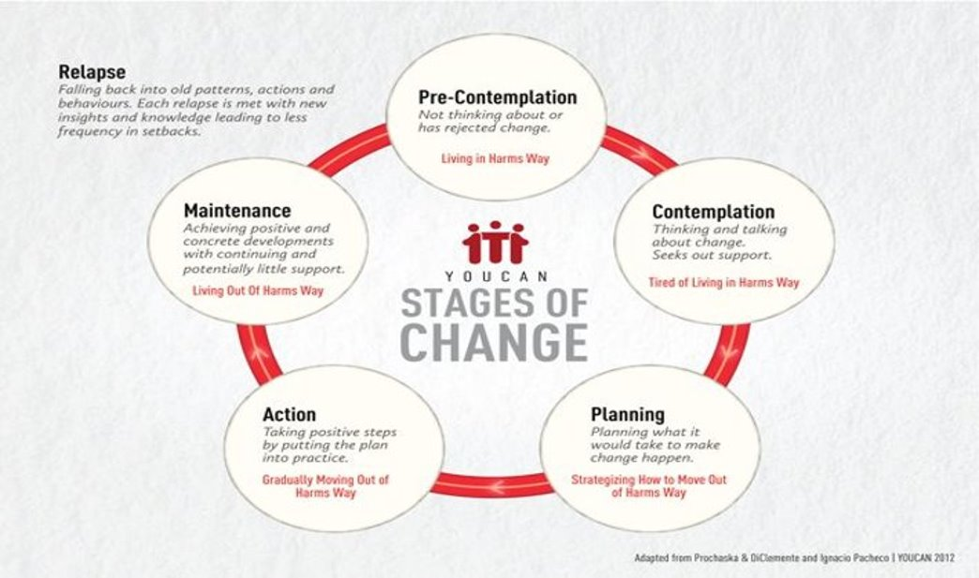
The stages of change recognize that change is difficult. It is not easy to get from first recognizing that there is a problem to the point of maintaining behavior change. The stages of change also recognize that the motivation to change is not stagnate and that the journey of behavior change is often not linear.
When people consider making a life change, they often spend time in the early stages of change, which requires patience from those supporting them. Difficult changes—such as addressing a substance use disorder—can include setbacks like lapses or relapses. After a relapse, a person may return to an earlier stage of change, such as contemplation, and need support that matches where they are. Providers play an important role by helping resolve ambivalence and encouraging progress. While motivation to change comes from within, providers can help individuals move closer to taking the steps they want to make in their own lives.

Think it Over:
Take some time to think about a behavioral change you have made in your own life (e.g.: cutting out sugar from your diet, quitting smoking, starting an exercise routine, spending less time scrolling). Think about the stages of change you went through in order to make that change.
- Did it take you a long time to realize something needed to change?
- How much time did you spend thinking about it or planning for the change before you took any action?
- Once you made the change, was it easy to maintain that or did you experience any relapse?
Understanding the difficulty and time involved in making these changes can give us compassion for parents in dependency cases that are asked to make a lot of behavioral changes in a short amount of time.

Activity 4.4 Stigma

Part 1: Read the following document regarding stigma.
📂 How to open the document:
- Double-click the PDF icon labeled “Disrupting-Stigma-Brief”
    - If it doesn’t open, right-click the icon, choose ‘Object’ from the menu, then click ‘Open’
    - If it still isn’t working, click on this link Homework to access it through the website.

Part 2: Read the document Birth Parents with Trauma Histories in the Child Welfare System – A Guide for Court-Based Child Advocates below.
📂 How to open the document:
- Double-click the PDF icon labeled “Birth Parents with Trauma Histories...”
    - If it doesn’t open, right-click the icon, choose ‘Object’ from the menu, then click ‘Open’
    - If it still isn’t working, click on this link Homework to access it through the website.

Refer to worksheet and answer the question.

Activity 4.5 Newborns Exposed to Substances: Hearing Mothers Voices

Read the following quotes from mothers who gave birth to newborns exposed to substances below:
Mother #1

Alice: “My third child, I had no prenatal care.”

Interviewer: “For what reason?”

Alice: “Because I was taking drugs, well, not drugs-drugs; I was down there smoking on marijuana and drinking liquor. And they told me if they see THC or something like that in my system, then protective services would get involved. So I didn’t go to no care for her, none.”

Mother #2
“I found out that I was pregnant in the middle of a relapse, and I thought I could not keep the baby. I did not feel motivated to keep the baby. I also felt shame and mortified in trying to get prenatal or drug treatment help—I knew they would judge me. They would also judge me if I lost the pregnancy. There was no way out. The thought of walking into a hospital and saying I am using was terrifying. To tell somebody what you have been doing is scary and the hardest thing to do because you don’t know how they are going to react.”
Mother #3
One woman was pregnant, using heroin, and incarcerated in her third trimester. A nurse in the jail said to the woman that she was a junkie and does not deserve to be a mother due to the damage she was doing to the unborn child. The woman said to the nurse, “Lady, there is nothing you can’t say to me worse than what I have already said to myself. Are you going to judge me or help me get help?”
From “Your Words Matter- Language Showing Compassion and Care for Women, Infants, Families and Communities Impacted by Substance Use Disorder” published by the National Institute on Drug Abuse November 17, 2023.
Refer to worksheet and answer the question.

Activity 4.6 Working with Families
Part 1: Read the document Shannon’s Story below and consider key factors in deciding recommendations for reunification or termination (severance) of parental rights. We will be discussing this in class, so if you’d like to keep notes, this story is also in your manual under Module 4.

📂 How to open the document:
- Double-click the PDF icon labeled “Shannon's Story”
    - If it doesn’t open, right-click the icon, choose ‘Object’ from the menu, then click ‘Open’
    - If it still isn’t working, click on this link Homework to access it through the website.
Refer to worksheet and answer the question.

Activity 4.7 What is Culture?
Culture refers to the shared customs, beliefs, and behaviors that people learn and pass on through common symbols and meanings. It can be understood as a set of learned responses and practical solutions that help individuals navigate daily life. Culture isn’t limited to race or ethnicity—professional groups, workplaces, and communities can all develop their own distinct cultures, complete with their own language, norms, and ways of operating. Ultimately, culture shapes how we act, how we think, and how we communicate.
There are many analogies that help us understand culture. One is that culture is like an iceberg: There are parts we can see and parts we can’t see but know are there. The part above the waterline makes up only about 10 percent of an iceberg’s entirety. The visible parts of culture might include dress, music, food and games. Those that we can’t see but know are there include unwritten rules guiding patterns of speech, concepts of time and the meanings of body language.
Review the Iceberg Concept of Culture Image below.
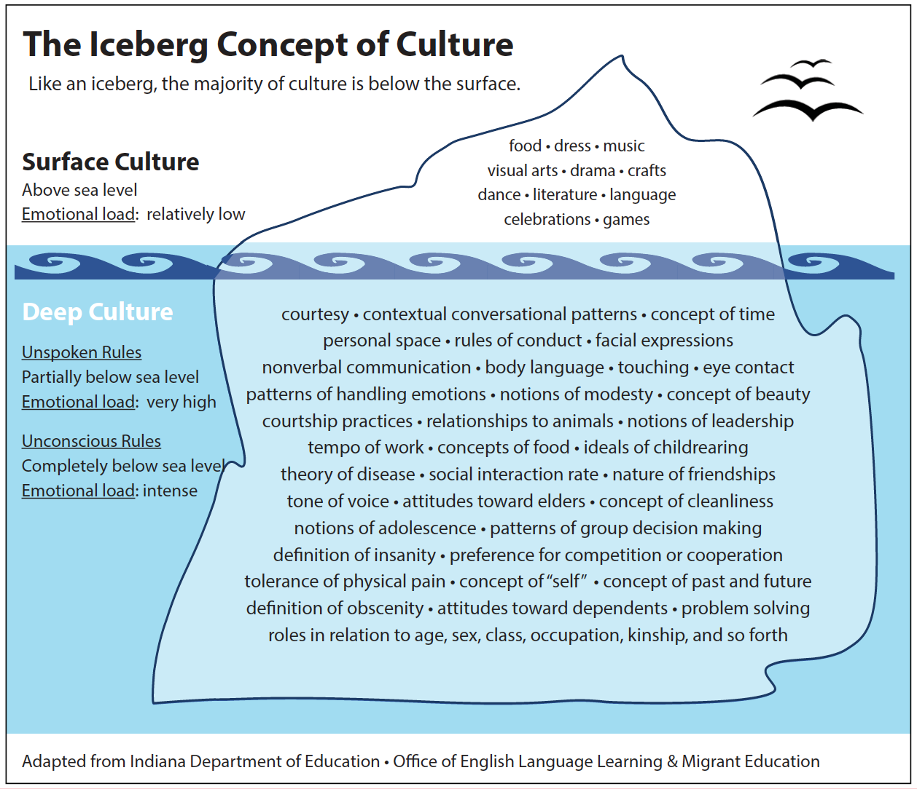
Refer to worksheet and answer the question.

Activity 4.8 Stereotyping vs Cultural Awareness, Responsiveness & Humility

Stereotypes vs. Cultural Humility
What are stereotypes?
- Rigid and inflexible beliefs about groups of people
- Remain even when evidence proves them wrong
- Harmful because they:
  - Limit people’s potential
  - Spread myths
  - Generalize unfairly
- Even “positive” stereotypes (e.g., “they are industrious”) are harmful because they are still limiting and generalized
What is cultural humility?
- A mindset that encourages us to:
  - Learn from the people we interact with
  - Reserve judgment
  - Bridge cultural differences
  - Promote well-being and quality of life
- Requires self-reflection:
  - Recognize your own biases
  - Understand that biases come from your life experience, not from truth about others
  - Everyone has biases and stereotypes sometimes
  - Developing cultural humility means:
    - Thinking flexibly
    - Practicing a beginner’s mindset (being open to learning continuously)
Child-rearing practices across cultures
- Practices in the U.S. that may seem harmful to others:
  - Children sleeping alone in separate rooms
  - Making children wait for food
  - Painful dental braces
  - Long hours sitting in classrooms
- Similarly, there are practices from other cultures that may be misunderstood in the U.S. One example:
  - Coin rubbing (Southeast Asia): heated coins rubbed on a child’s body to reduce fever, chills, or headaches
    - Leaves red streaks or bruises
    - Can be mistaken for child abuse if the cultural meaning is not understood

Checklist for Volunteers: Examining Personal Bias

As a CASA volunteer, ask yourself:
- Have I made assumptions about this family’s cultural identity, gender roles, or background?
- Do I truly understand this family’s unique culture and circumstances?
- Are my recommendations tailored specifically to this child and family?
- What evidence supports my conclusions? Have I challenged any assumptions that lack support?
- Have reasonable efforts (or active efforts in ICWA cases) been made to meet the family’s needs in an individualized way?
- Have relatives been fully considered as preferred placement options, provided they can protect the child and support permanency?
- Are there family members or other important people who should be contacted but haven’t been?
- What services are being offered to keep the child at home or reunify the family? Are these services culturally appropriate and connected to the safety concerns?
- Is this child and family receiving the same level and tailoring of services as others?

Practicing cultural awareness in advocacy
Respect and Learn About Other Cultures
- Respect cultural norms, values, traditions, and parenting styles.
- Accept differences and learn from families’ perspectives.
- Ask respectful questions and practice curiosity.
- Show genuine interest in families’ needs.
- Follow appropriate protocol: show respect based on others’ values.
- Families are usually open once they see you are sincere and respectful.
Build Connections
- Meet families where they are; don’t force them to fit your standards.
- Use collaborative networks (faith groups, community organizations, natural supports).
- Recognize relationships are reciprocal—give something back.
Keep Growing
- Understand that learning across cultures can be challenging—allow mistakes and apologize when needed.
- See cultural humility as a lifelong journey.
- Be courageous: speak up when you hear biased thinking.
- Expand your circle to include people of different races, cultures, values, and beliefs.
Remember: Each child and family is unique, shaped by culture, family, and personal traits.

Adapted from materials developed by CASA for Children, Inc., Portland, Oregon.
Refer to worksheet and answer the question.

Activity 4.9 Educational Challenges for Children in the Child Welfare System

Most children have parents who monitor their academic progress, attend parent-teacher conferences, enroll them in appropriate classes and generally ensure they receive a high-quality education. When these children do not receive appropriate educational opportunities, their parents speak up on their behalf. Foster youth frequently lack such educational advocates. As a consequence, they often fail to receive the educational opportunities they need to succeed in school and, as a result, fall behind their peers academically. As a CASA volunteer, you can help advocate for a child’s educational needs.
Teachers who see the child every day have a wealth of knowledge about the child’s behavior, attitude, likes and dislikes, and about the best ways to communicate with that child. As you inquire about a child’s progress in school, you may discover that the child has special educational needs and should be referred for an evaluation. In some areas, an abundance of resources may be available for special-needs children; in other areas, you may have to advocate for the creation of needed resources.
It is important to realistically assess the school difﬁculties of a child and determine how the educational system, as well as the child’s particular school setting, may be creating or sustaining those problems.

Activity 4.10 Rosa Case
Rosa Case:
Up to this point, you’ve reviewed the Dependency Petition, the initial DCS report to the court, and CASA contact logs.
Now, you will read:
- The DCS Progress Report submitted before the upcoming Review Hearing
- The Minute Entry dismissing the case as to Israel
- Additional updated case documents included in the PDF
Timeline Recap:
Children removed → January 2024
Initial hearings → January 2024
First Review Hearing → June 2024
Next Review Hearing scheduled → September 2024
Instructions:
Click the PDF below to read the most recent Rosa case documents. As you review the materials, take notes on key details. In upcoming classes, you’ll work in groups to consider:
- What information belongs in the assessment section of the CASA court report (for the Sept 2024 Review Hearing)
- What to include in the opinions & concerns section
- What recommendations you may ultimately make for this case

📂 How to open the document:
- Double-click the PDF icon labeled “Module 4 – Rosa HW Documents”
    - If it doesn’t open, right-click the icon, choose ‘Object’ from the menu, then click ‘Open’
    - If it still isn’t working, click on this link Homework to access it through the website.
Refer to worksheet and answer the question.

Activity 4.11 Assessment Section Rewriting Practice

Read each of the following statements from the assessment section of a court report, then indicate how you would re-word the statement. Remember the assessment section should only contain fact-based statements without personal opinions or interpretations.

- “Ms. Rosa screwed up and smoked smack.”
- “Mr. Alvarez has never been a father to Israel”
- “Mr. Lopez seems to not care about the case.”
- “Jimena appears to be depressed.”

Refer to worksheet to complete this section.

Citations
American Psychological Association. (Updated 2023, November 15). Substance dependence. In APA Dictionary of Psychology. APA Dictionary of Psychology
American Society of Addiciton Medicine. (n.d.). Definition of addiction. What is the Definition of Addiction?
National Center on Substance Abuse and Child Welfare. (2023, October 26). How to Use Data for Change: Improving Outcomes for Families Affected by Substance Use. How to Use Data for Change: Improving Outcomes for Families Affected by Substance Use - AD - YouTube
National Institue on Drug Abuse. (2023, November 17). Your Words Matter-Language Showing Compassion and Care for Women, Infants, Families, and Communities Impacted by Substance use Disorder. Your Words Matter – Language Showing Compassion and Care for Women, Infants, Families, and Communities Impacted by Substance Use Disorder | National Institute on Drug Abuse (NIDA)
Substance Abuse and Mental Health Services Administration. (2022). 2022 National Survey on Drug Use and Health (NSDUH) Annual National Report. 2022 NSDUH Annual National Report | CBHSQ Data

